**DEENBANDHU CHHOTU RAM UNIVERSITY OF SCIENCE AND TECHNOLOGY**



**Submitted To : Submitted By:**

**Dr. ANITA SINGHROVA PAYAL**

**CSE Deptt. B.Tech (CSE 3rd year)**

**Roll No:15001001037**

**A Project Report**

On

**“BANK MANAGEMENT SYSTEM”**



Software Requirements Specification

Bank Management System

Team Member

Payal

CSE 3rd year

15001001037

Platform

Netbeans

Organization

Aptech Computer Education



Mentor

Abhishek Paul

Contact - 9910590763

Email Id –abhishekpaul@live.in

**About Institute**

I did my java core Training from “Aptech Computer Education” in time period (3rd june, 2017 to 10th august, 2017).Aptech Computer Education is a premier education institute with 30 years of experience in IT training. The institute provides a wide variety of career, professional, short term courses with certification. All the courses are taught by experienced and certified faculty. Their trainers constantly update their skills to maintain their expertise.

**Acknowledgement**

I am really grateful because I managed to completed my project “**Bank Management System**” with in the time period given by our teacher. I want to say sincerely thanks to my mentor “ **Abhishek Paul** ” because this project cannot be completed without the effort and co-operation from my mentor . He encourage me and also teaching me very effort fully and doing clear my all doubts. I want to say thank to my lecturer who help me and always available to me in all the time and short out my all the problems.

Table of Contents

1. Introduction

1.1 Need and Purpose

1.2 Document Conventions

1.3 Intended Audience

1.4 Project Scope

2. Overall Description

2.1 Features and Functions

2.2 Users classes and Characteristics

2.3 Operating Environment

2.4 Data Flow Diagram

2.5 E-R Diagram

3. Specific Requirements

3.1 Performance Requirements

3.2 Design Constraints

3.3 Data Requirement

4. Product Feature

5. System Features

5.1 User interface

5.2 Back ground Activity

6. References

1. Introduction

1.1 Need and Purpose

In present times, all major economic transactions have started taking place digitally .The major trends of modern digital transactions is substantiated by use of database management .These databases can be accessed by anyone with specific rights, and perform certain actions on it. The data update is done almost automatically and is much faster.

Users can, in present days can access their accounts directly without going to a bank, making transfers ,transactions and accessing cash directly without standing in a queues.

On employee-side the data is much more organised, and accessing and performing actions on user accounts is easier for them. Due to this the bank has better work efficiency and customer experience improves as well.

Requirement and Specification

* Netbeans IDE 8.2
* Jdk tool

1.2 Document Conventions

In general, this document prioritizes in writing the schema of the database management mechanism that takes hold in this project and then analyzing in detail the tools that are available in the Bank Management System and account related details in database system. Therefore there are lots of abstractions to represent in a more convenient way the objects and their behaviour on the system. Every requirement statement is assumed to have its own priority as to define in most appropriate way the system behaviour .In addition there are various figures that represent the described system, where it is needed, and serve only for better understanding of the deployment

1.3Intended Audience

Developer

The developer who wants to create, read, change, modify or add new requirements into the existing program, must first consult this document and update the requirements with appropriate manner so as to not destroy the actual meaning of them and pass the information correctly to the next phases of the development process.

Bank Employees

They can easily keep records of all the transaction and other details related to account holder very conviently.

Research students

Research students are advised to read all the sections of this document to get overall idea of the work flow and technicalities of the software.

Tester

It can be used as a documentation to know the interfaces.

1.4 Project Scope

This Application Bank Management System offers easy way to organize the details of the account holders and their transaction details in the database.

The benefit of this is that they can easily access the details of the account holder and their corresponding details like all their transactions and withdrawl. But in this application all the users have their different accessibility .So the systems are secure. By use of this application, it provides a convenient and safe means of transferring money from one place to another.

2. Overall Description

2.1 Features and Functions

Features:

Bank management system can be used by bank employees and customers depending on bank policy. It can be used by several employees of the bank at their own systems with required rights. In this the data can be accessed depend on the accessibility of the user.

It can be deal with the banking functions like new account registration, withdrawl, deposit, money transfer etc.

Functions:

EWS (Employee Work Space ) requires employee login. It handles following

1. New Customer Registeration
2. Transactions
3. Detail Updation
4. Deposit
5. Withdraw
6. Account Summary

2.2 Users classes and Characteristics

Bank front-end employee : The bank employees would be the main users of the bank management system .They may perform banking functions using EWS or may facilitate customer .

Bank Customers : The customers would be able to use this application by login ,if bank wants to provide user with direct access.

2.3 Operating Environment

2.3.1 Hardware

It requires an entry level PC for smaller number of bank accounts (like when data is being stored locally).For larger no. of bank accounts, a server class machine is recommended.

2.3.2 Software

Its server can run on any recent version on windows, linux etc. There are many servers available as a open source to all and free of cost to download .One of the server is Xampp Server. It requires:

1. Apache 4.5 or later

2. Tomcat 5.6 or later

2.4 Data Flow Diagram

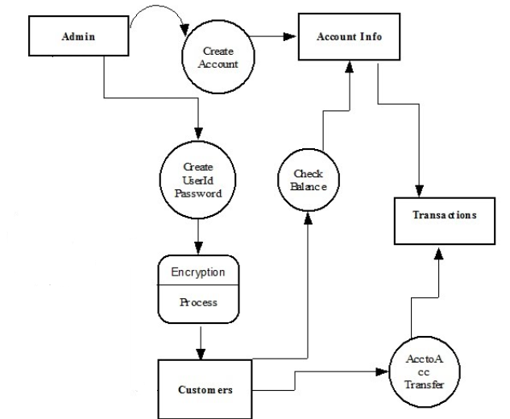

2.5 E-R Diagram

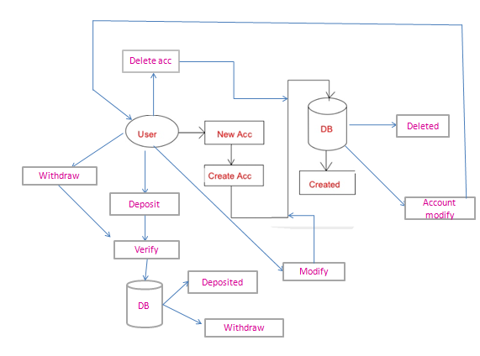

3. Specific Requirements

3.1Performance Requirements

Database can store details of hundred thousand of accounts, but that can vary according to banks need, and would depend on data storage capacity of server and not on database.

The respond time depends on size of database due to searching process, but still the response by server will be just the time to search, as it would be accessed from specific devices in the bank.

3.2 Design Constraints

Enhancement to the security features might lead to performance overhead.

3.3 Data Requirement

The product is completely data oriented.

The employee would input the various details of Customer for updating, processing or retrieval of data and for new customers, required fields for registeration will be filled.

Description or screenshots of Project

* PAGE 1

When we start the project , some welcome pages open this will automatically disable after 7 seconds and load the login page automatically.

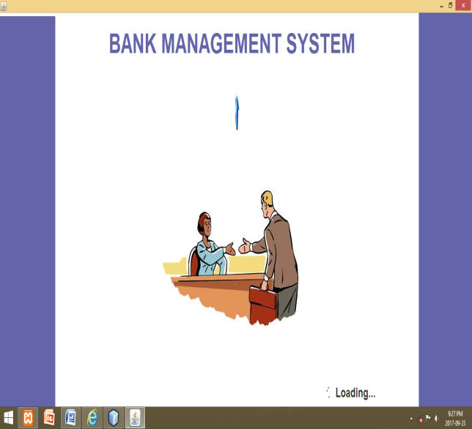 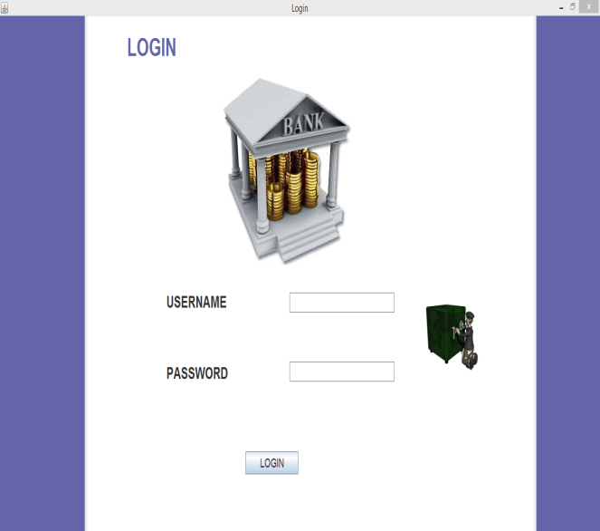

1. There are two options for user.

2. User will enter the username and password.

3. Then it check the data is exist in database or not.

4. After that it opens the next page.

* PAGE 2

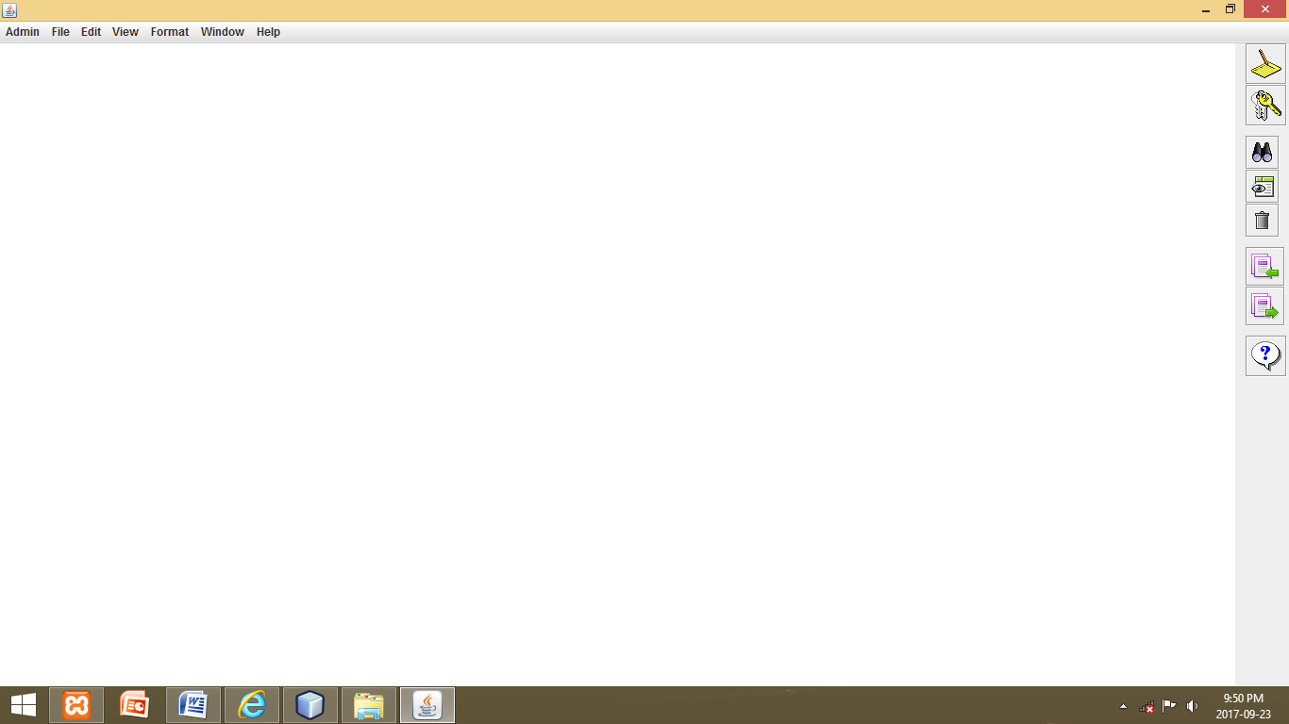

There are different menu items present on menu bar given below :

1. Admin: In admin there are further four options .

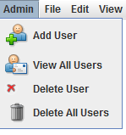

1. Add User: This feature is only available for admin .Admin can add new user with their accessibility.
2. View All Users : In this admin can view list of all user available in the database.
3. Delete Users: In this admin can delete any user from present database.
4. Delete All users :In this all the user are remove from the database.
5. File: In file there are further three options.

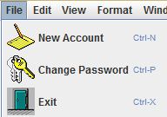

1. New Account: In this admin and manager, can add new account holder with details.
2. Change Password: In this admin, manager and user can change their own password.
3. Exit: Exist can close the project.
4. Edit: In edit there are further five options.

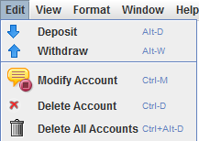

a. Deposit: Deposit money.

b. Withdraw: Withdraw money.

c. Modify Account: Modify account details.

d. Delete Account: Delete account from existing one.

e. Delete All Account: It will delete all the existing account from the database.

4. View: There are further five options.

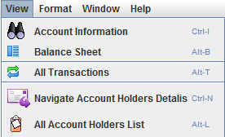

1. Account Information: In this admin,manager and user enter the account id and corresponding details appear automatically from the database.
2. Balance Sheet: In this by account id we can see the balance sheet of the account holder.
3. All Transaction: In this all the transactions till now appears simultaneously.
4. Navigate Account holders Details:In this admin can see all account holders detail one by one.
5. All Account holder list: from this all the account holder present in the database appears in the form of list.

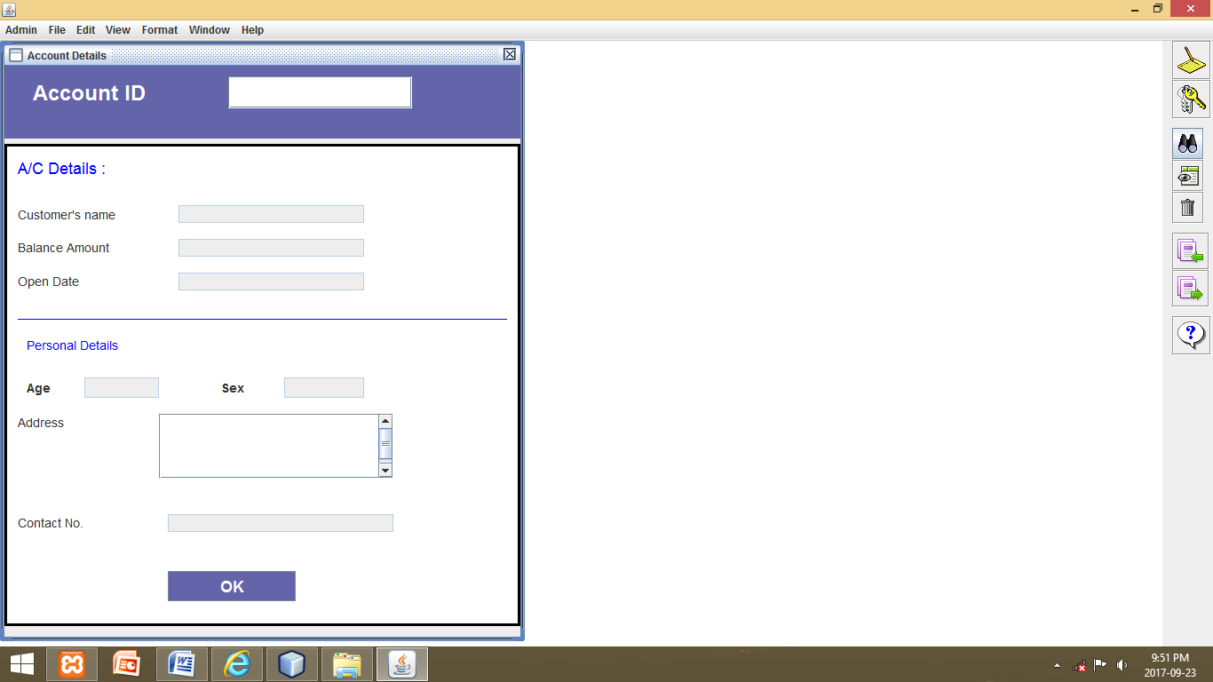

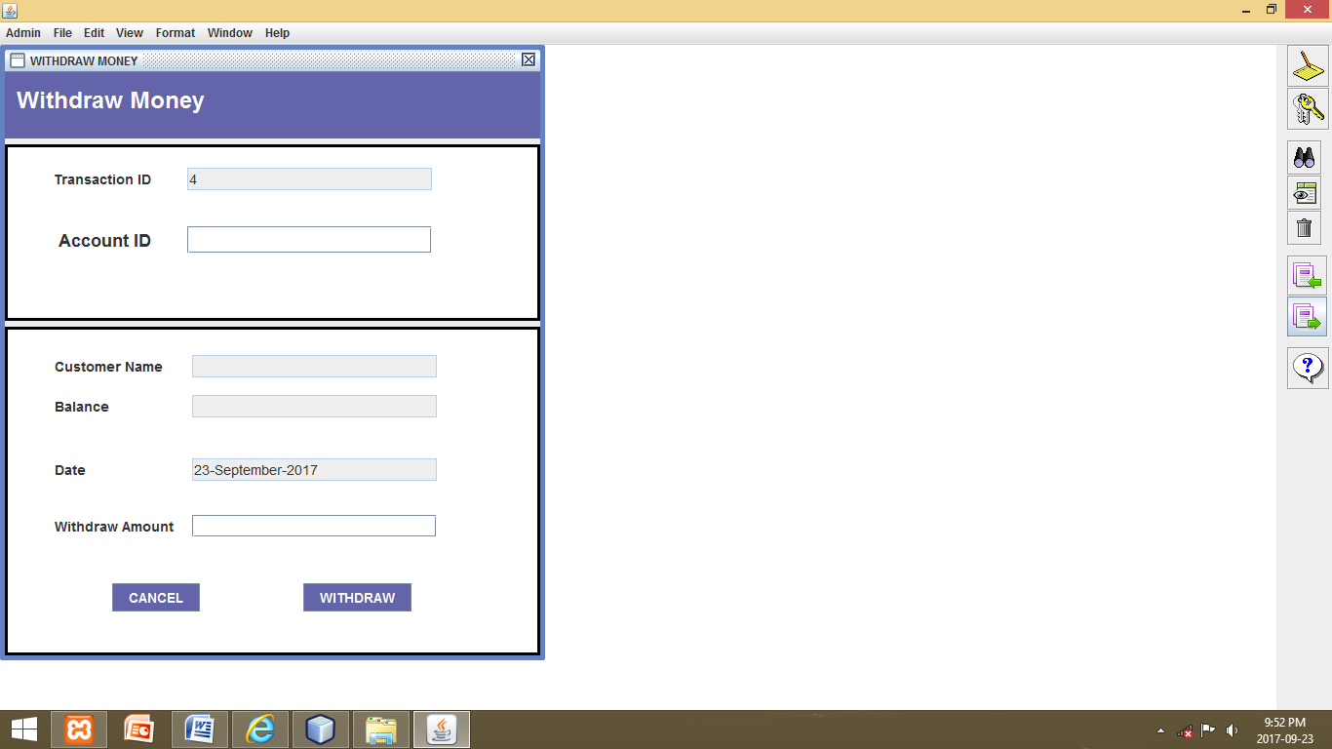

4. Product Features

a. Check your account balances, review activity and access account history.

b. Transfer funds between accounts.

c. By this, account holders information are secure.

d. It makes management of money very simple and convenient.

e. It makes employee tasks very easy.

f. Through this user can change password very easily.

g. Access personal deposit account statements.

5. System Features

5.1 User Interface

a. User only interact with the screen of device or front end of the application.

b. User interact direct with the first page or follow the instructions.

c. Front end use a user interface.

5.2 Background Activity

Mysql(Database)

1. Store the data in the database for compare the username and password.
2. When user enter the username then it check the username is true or exist in the database or not.
3. After that if username is not matched then it shows username is invalid.
4. If username and password is valid then it procced to next page.
5. All the updation and deletion user made at that instant of time is stored in the database.
6. It means that the database is the active part of any project which needs to be continuous updates.

6. References

* [www.javatpoint.com](http://www.javatpoint.com)
* [www.tutorialspoint.com](http://www.tutorialspoint.com)